M10 ULTRA by Medialink Specification Sheet
Extreme High 8K Performance

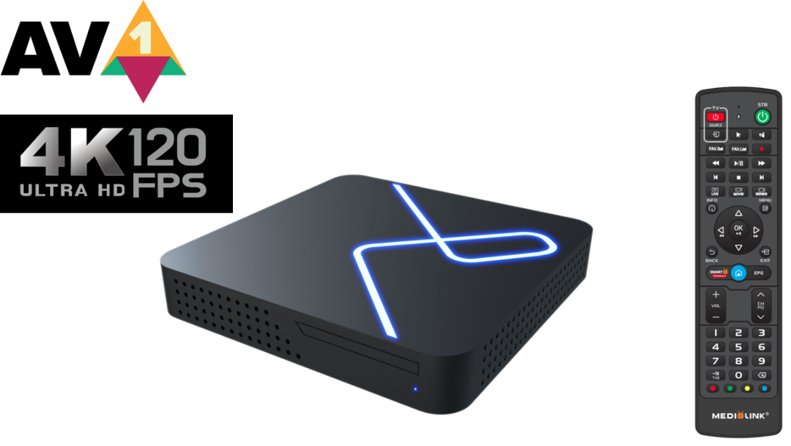

Specifications

- Maximum Output Resolution: 8K (7680 × 4320)
- Standard Output Resolition: 4K (3840 x 2160) 120fps
- CPU : Amlogic S905X4 Quad-core Cortex-A55 up to 2.1 GHz
- Amlogic S905X4 will be slightly faster due to the higher (default) maximum CPU frequency of 2.1 GHz
- AV1 video codec up to 4K@120fps
- AV1 saving 30% more bandwidth efficiency compared to H.265 or VP9
- GPU : Arm Mali-G31MP2 with support for OpenGL ES 3.2, Vulkan 1.0/1.1, and OpenCL 2.0
- RAM: 2GB Highly Compressed
- Storage: 16GB eMMC
- Operating System : Android 10.0
- TV System: Smart TV Online 2

Networking
- Wireless : 5.8GHz Dual-Band 2x2 AC Wireless
- BT : 4.2
- Ethernet : 1000Mbit Extreme high Speed GIGABIT LAN

Decoder
- Video decoder : 8K@30fps, 4K@120fps, H.265(HEVC), AVS, H.264(AVC, MVC), Real, MPEG1/2/4, VC-1
- AV1 Video Decoding
- Audio decoder : MPEG-1 Layer 1,2,3(2-CH), MPEG-2 Layer 1,2, HE AAC V1/V2
- Support Language: All Language
Dimensions
- Length: 105mm
- Width: 105mm
- Thickness: 19.5mm
- Color: Black
- LED Color: Cold White

Power input
- Power: 5VDC / 2A
- Power Supply: USB Type C
- Power Consumption : Max. 12W
- Standby Power : Max. 0.5W (Ultra low power)

Accessories
- M10 Extreme High Performance 8K Box
- Medialink Exclusive Backlight Remote Control
- 5V2A Power Supply
- USB Type C Cable
- 8K HDMI Cable
- 2* Original AAA Batteries for RCU
- User Manual in 6 Languages (EN, DE, FR, ES, IT, AR)

