Instruction manual
DVBM-15/DVBM-15H |  | 
DIGITAL HD SINGLE-CHANNEL HDMI TO DVB MODULATOR.

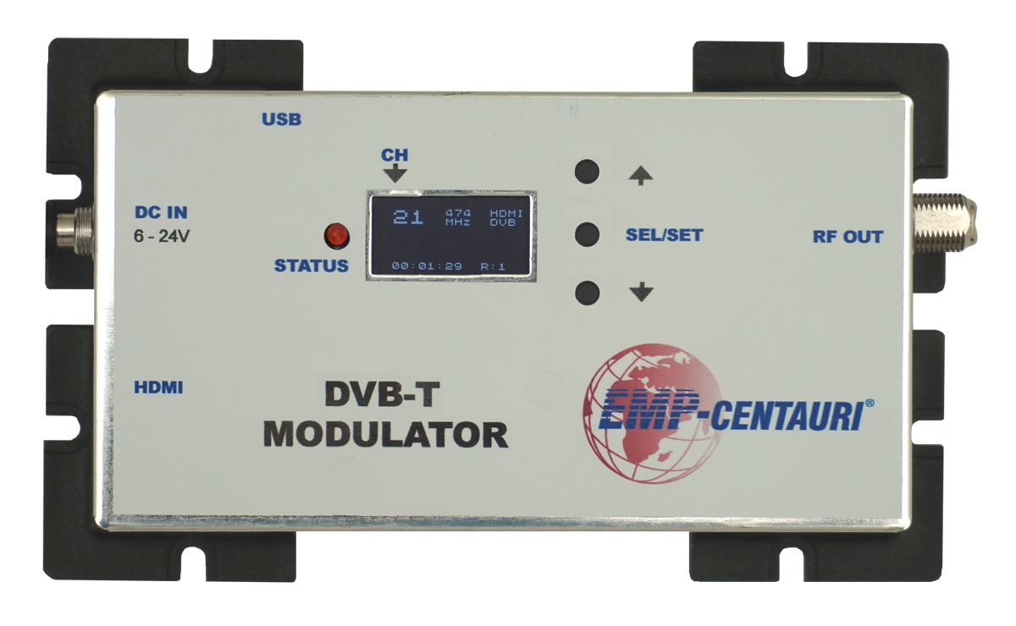

Modulator has one HDMI input and one DVB-T/ATSC/DTMB standard RF output. Also it supports playback from PC via USB to DVB-T/ATSC/DTMB .

Designed for real time encoding of any HDCP compliant signal and sending it out via built in frequency DVB modulator.

Produces excellent quality signal output with 40 db MER, compatible with a variety digital TV tuners.

EXTERNAL VIEW AND CONNECTIONS
3

2
4

1

5

1. HDMI input. Connect multimedia source to this input by HDMI cable.
2. DC power input. Connect 6-24V AC adapter to this input. ATTENTION! Please unplug AC adapter from power outlet before connection. For safety and make modulator work properly use ONLY original AC adapters.
3. USB input. Use USB 2.0 mini B to USB 2.0 A male cable (not included) to connect modulator to the PC.
4. RF output. Standard 75 Ohm impedance output F-connector to connect coaxial cable.
5. Mounting holes. Use this holes to fix the modulator on the wall or other surface. Otherwise the plastic corners can be removed from modulator housing.

ATTENTION!
For safety and to minimize the risk of modulator damages, please, disconnect the AC adapter before performing any connection.

CONNECTION EXAPMPLE

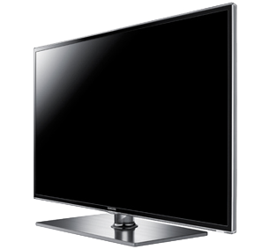
TV1
TV4

......
Coax cable
Coax cable
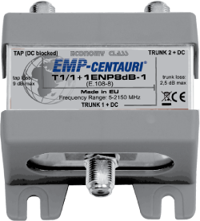
SPLITTER

HD RECEIVER
BD PLAYER
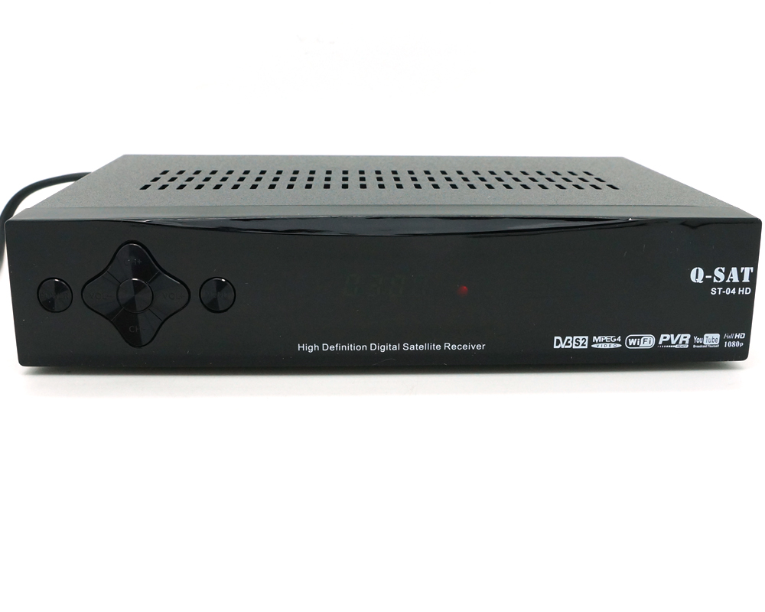
UHF DVB-T
HDMI

OPERATING
When switching the device ON, it needs some short time for loading (Status led flashing fast and channel number is zero). After loading will be displayed curent setings and device status.
Frequency
Input source
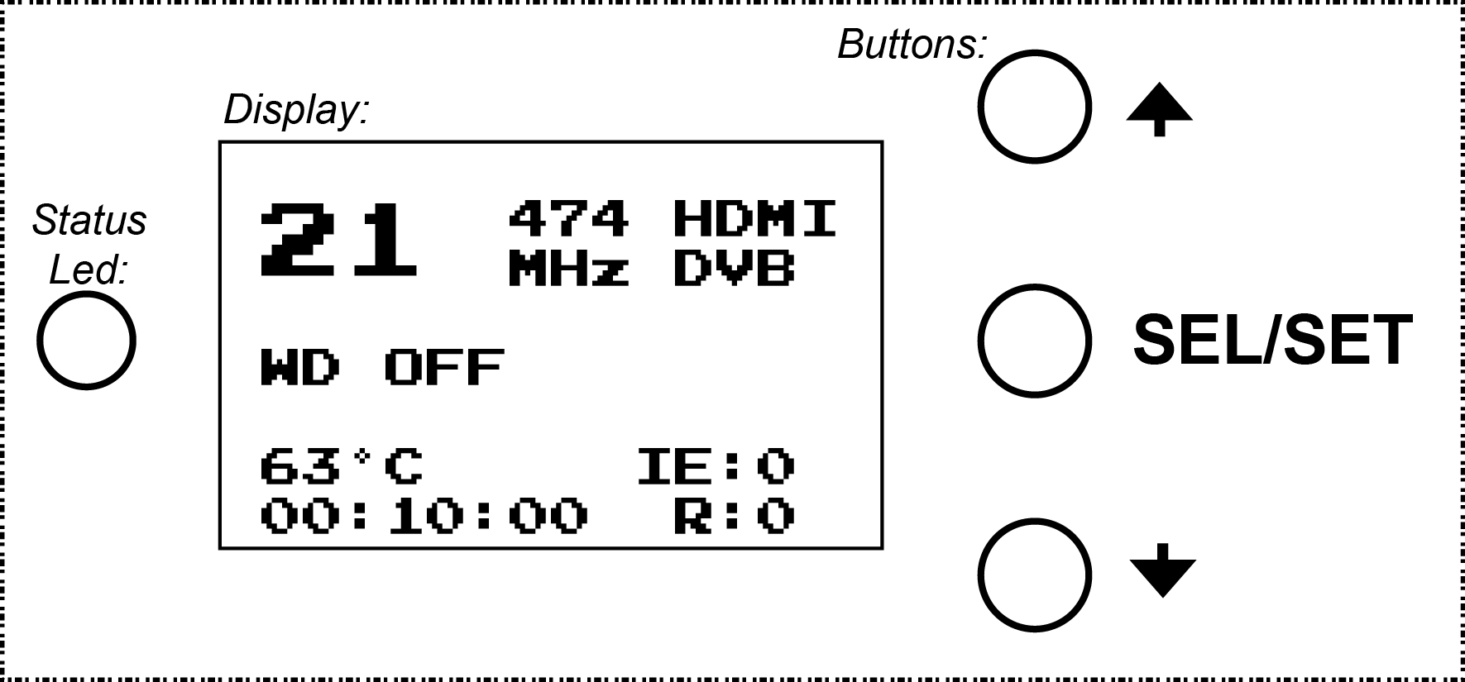
Channel number
Output
Watchdog status
Transmitter temperature
Working time
Errors count

Channel number
Displays the number of transmission channel. The channel can be configured in the settings.

Watchdog
If the modulator will running long time without maintenance we recommend to swich the watchdog ON (WD ON). In this case, the main controller will monitor the device status and in the event of an error or hang, automatically reboot the modulator.

Transmitter temperature
This option indicate the current temperature of the transmitter part. Working temperature should be not higher than 120 °C. If the temperature is out of the operating range, the device automatically turns off.

Working time
Displays device operating time.

Errors count
IE shows HDMI errors count.
R shows encoder resets count.

Output
Indicates the output transmission standard.

Input source
Displays the input signal source.

Frequency
Displays the output frequency in Megahertz.

Settings


To change settings long press SEL/SET button (for more than 1 second), the channel number is inverted and can be changed by buttons. At this point short press the SEL/SET button to make a selection of the next option (next option is WD on/off). Press the SEL/SET button again and display shows next options list (input source setings, output setings, etc.). All times use SEL/SET button to switch between options and
buttons to change option settings.

To save all changes long press SEL/SET button (for more than 1 second). Changed parameters will be writed to the device memory. The Status Led will blinking fast, and after several seconds modulator will restart with the new settings.

To reset the modulator manualy pres an hold the button.
In a special case, if channel number are zero, pres button to read current settings from memory.

Example of change settings from DVB-T to DTMB
Long press SEL/SET. By clicking SEL/SET button (3x click...) move to second page of settings to the “DVB” option.

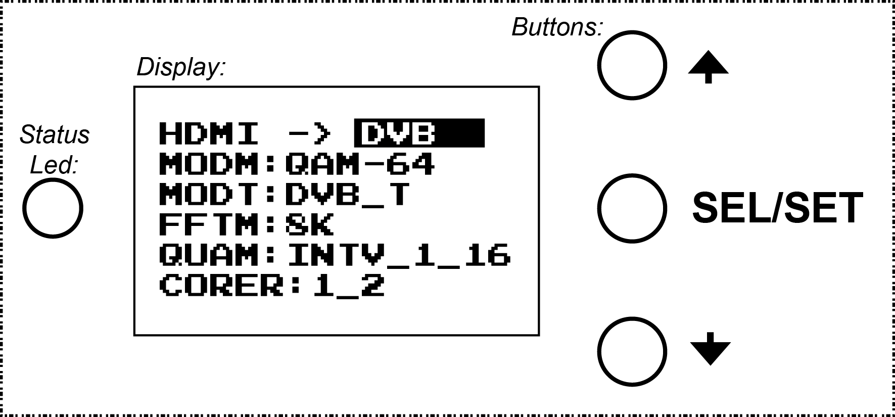
Press button for selecting DTMB. Long press SEL/SET button to write changes to device memory.
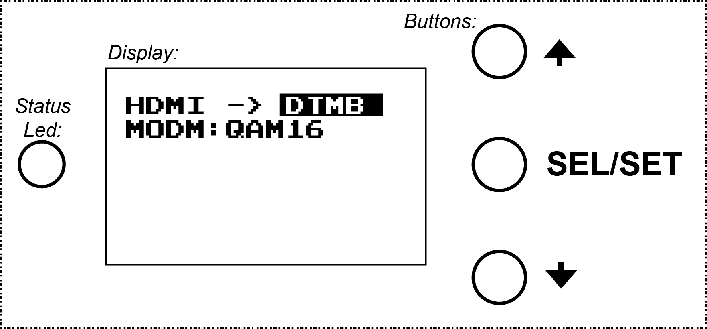

In this way, it is possible to change any device parameter.

Specifications:
Output connector type: F-connector
Working frequency: 300-900 MHz (8 MHz step)
Output level: 75 dBuV (105 dBuV for DVBM-15H)
MER: ≥ 40 dB
Power: 6-24V 2.9W DC
Inputs: USB,
HDMI 1.2 ITU BT.656/BT.1120 (8bit/10bit) support RGB or YcbCr colour space;
Supported resolutions: SD/HD/FHD (480i/480p/576p/720p/1080p).
Transmission standards: DVB-T, ATSC, DTMB;
Modulation: QPSK, 16-QAM, 32-QAM, 64-QAM, 8 VSB, QAM4-NR;
Carrier: 2k, 4k, 8k, single/multi;
Guard interval: 1/4, 1/8, 1/16, 1/32;
Bandwidth: 2~8 MHz;
Audio codec: MPEG-1.
Video codec: MPEG-2 Main@Main, Main@High 480i/480p/576p/720p/1080p;
H.264 Main@Main 480i/480p/576p only;
Quant Control: adjustable - 1~31 (MPEG-2).
Bit rate: adjustable according to modulation bandwidth – 3Mbps~22Mbps (15Mbps typ.)
Adjustable: Service Provider Name, Service Name, Program ID, Network ID,Video PID, Audio PID.
Auto null packet fill up.

Table of DVB-T channels/frequencies
Cannel | Frequency, MHz | Cannel | Frequency, MHz | Cannel | Frequency, MHz
21 | 474 | 38 | 610 | 55 | 746
22 | 482 | 39 | 618 | 56 | 754
23 | 490 | 40 | 626 | 57 | 762
24 | 498 | 41 | 634 | 58 | 770
25 | 506 | 42 | 642 | 59 | 778
26 | 514 | 43 | 650 | 60 | 786
27 | 522 | 44 | 658 | 61 | 794
28 | 530 | 45 | 666 | 62 | 802
29 | 538 | 46 | 674 | 63 | 810
30 | 546 | 47 | 682 | 64 | 818
31 | 554 | 48 | 690 | 65 | 826
32 | 562 | 49 | 698 | 66 | 834
33 | 570 | 50 | 706 | 67 | 842
34 | 578 | 51 | 714 | 68 | 850
35 | 586 | 52 | 722 | 69 | 858
36 | 594 | 53 | 730
37 | 602 | 54 | 738

SAFETY INSTRUCTIONS
Installation of the modulator must be done according national safety standards.
The modulator AC adapter is powered from mains 230V~. This voltage is dangerous to life.
Any repairs must be done by a qualified personnel.
To avoid the electric shock follow these instructions:
do not remove the cover of the AC adapter, without disconnecting the unit from the mains supply;
do not plug the modulator AC adapter into the mains supply if the power cord or plug are damaged;
do not plug the modulator AC adapter into the mains supply until all cables have been connected correctly;
to disconnect the modulator from power completely, disconnect AC adapter plug from mains socket;
the mains socket must be easily accessible;
modulator shall not be exposed to dripping or splashing water and no objects filled with liquids, such as vases, shall be placed on it;
avoid placing modulator next to central heating components and in areas of high humidity;
before connecting the modulator to multimedia system, be sure that system is installed in accordance to national safety standards;
devices of multimedia system should have easy access to disconnect them from the mains supply;
no naked flame sources, such as lighted candles, should be placed on modulator;
the ventilation should not be impeded by covering the ventilation openings with items, such as newspapers, table-cloths, curtains;
from top and on the sides of installed modulator must be at least 2 cm free space.

